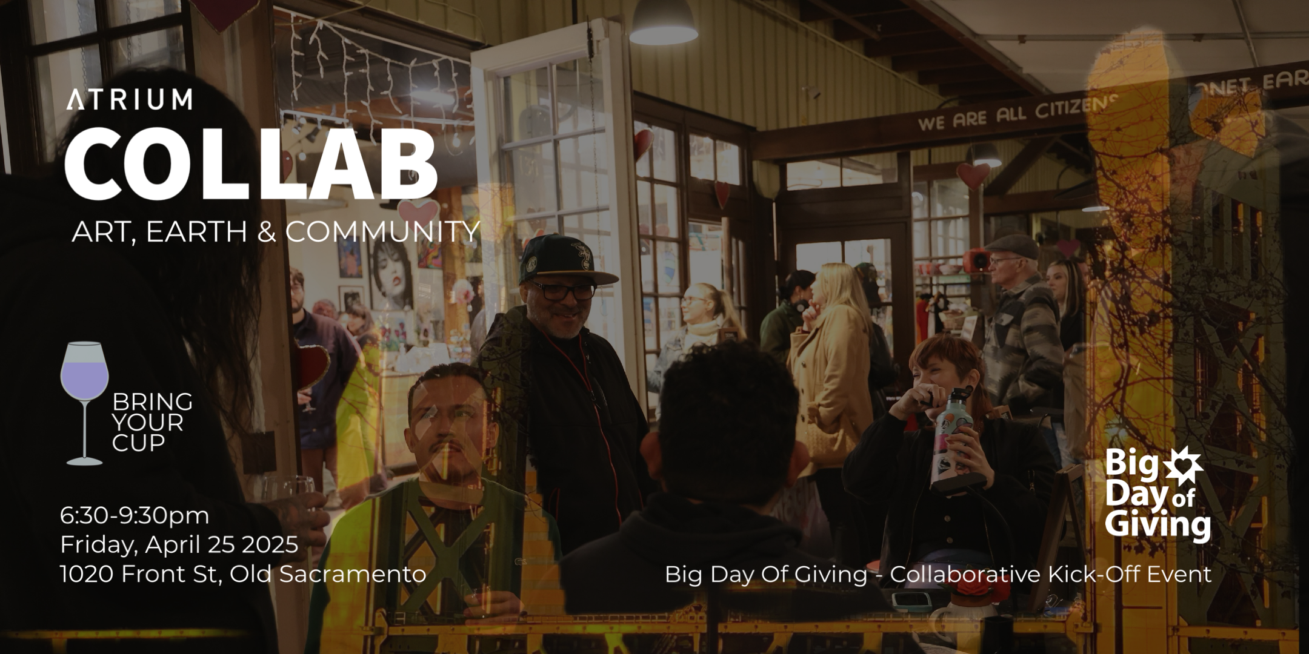

**COLLAB: ART, EARTH, & COMMUNITY**

An Evening of Art, Intention, and Investment in What Matters

“Collab” is a dynamic celebration of creativity, sustainability, and community, taking place on Friday, April 25th, as part of Earth Week. This vibrant event will feature music, drinks, and art and kick off the final five days leading up to the Big Day of Giving. Guests will have the opportunity to meet and connect with some of the nonprofits participating in this year’s Big Day of Giving, the Sacramento Region Community Foundation’s annual giving event, happening on May 1st.  
  
Bring your cup for a zero-waste experience in beautiful Old Sacramento. The bar has drinks, and the event has art, music, and good vibes. Engage with many creative artists, either live painting, making jewelry, or artists working on community installations, and engage with amazing nonprofits in our community and the projects they are cultivating for our community. Meet in person the organizations you would like to donate to this year for Big Day of Giving.  
  
This outdoor spring evening event is happening in romantic Old Sacramento by the river at the Atrium 916 complex. Guests will have the opportunity to participate in a variety of engaging activities, including:

* **Get Creative at the Art Café**: Unique art-making experience where you can sculpt a clay magnet or paint your own canvas or reusable tote bag.
* **Experience ZMAC - Zero Waste Mobile Art Café** - An upcycled 1950s horse trailer turned solar-powered Mobile Art Café.
* **Create Chalk Art** - Create your own chalk art on the large chalkboard or get creative on the sidewalk.
* **Live Art Installations**: Participating artists will create pieces live during the event; some completed works will be raffle prizes.
* **Tour the Atrium Art Studios**: Explore the inspiring workspaces of our resident artists and discover their creative processes firsthand.
* **Sunset Beats:** Music spun by Elliot Leach
* **Sip and Celebrate**: Savor refreshing drinks available throughout the evening
* **Donation Perks**: Help local artists thrive! For every $25 donation, guests will receive a “golden ticket” to enter raffle prize draws or exchange for a drink.

Connect with local artists, support sustainable organizations, and enjoy a vibrant community atmosphere. We welcome friends and family for an evening filled with art, music, and inspiration.  
  
**Event Name:** COLLAB: Art, Earth, Community

**Date:** Friday, April 25th, 2025

**Time:** 6:30 PM - 9:30 PM

**Location:** Atrium - 1020 Front Street, Old Sacramento, CA 95814

**Cost:** free

**Signup:** [Eventbrite](https://www.eventbrite.com/e/collab-art-earth-community-tickets-1309179102939)

**EPK:** [Electronic Press Kit with Photos](https://www.dropbox.com/scl/fo/vklb0pi58185ey5dihomu/ANOZrjCVlX_g6BsqcEXaSfg?rlkey=tipn9kh75octlke8uiabc6d4g&e=1&st=5pu99sp9&dl=0)

**Website:**  [www.bigdayofgiving.org/organization/Up-Kindness](http://www.bigdayofgiving.org/organization/Up-Kindness)

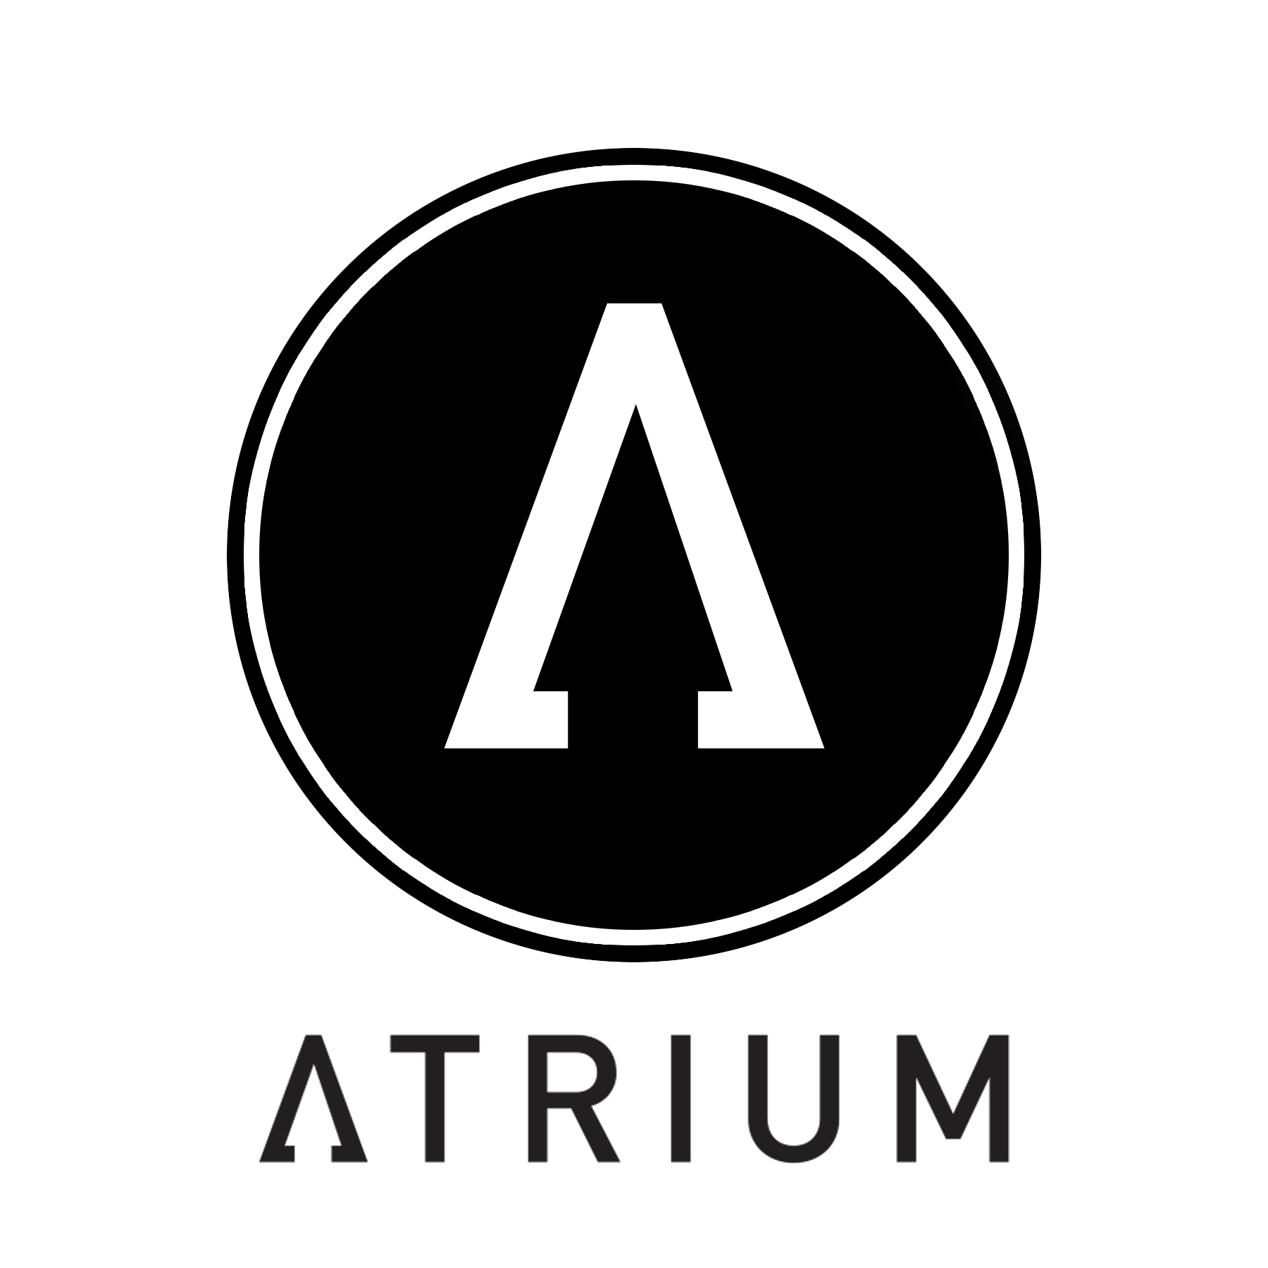

**About Atrium 916:**

Atrium 916 is a Creative Innovation Center for Sustainability, a nonprofit organization dedicated to building a kind, creative, and sustainable future. Through impactful solutions, education, art, and events, the Atrium serves as a collaborative hub where creatives come together to innovate, educate, and work towards a regenerative future that our planet needs.

Supporting over 850 eco-conscious artists and entrepreneurs in the Sacramento region, Atrium 916 offers economic development programs, sustainability solutions, advocacy, and affordable artist studios. We are at the forefront of advancing the circular economy and local creative industries, advocating for and executing initiatives that elevate both.

Atrium 916 welcomes over 148,000 visitors annually and serves as a vital space for piloting consumer-facing reuse and circular systems. Sacramento.Shop, a gallery and sustainable gift shop within Atrium showcases local artists and makers from Sacramento County. Recognized as one of the most unique eco-friendly destinations in Northern California, the shop features floor-to-ceiling accordion French doors, offering a seamless indoor/outdoor experience. [www.Atrium916.com](http://www.Atrium916.com)

**About Big Day of Giving:**

Big Day of Giving is a community-wide movement to support local nonprofits, organized by the Sacramento Region Community Foundation since 2013. This year, more than 850 organizations are participating, each working to make our region stronger, more vibrant, and more equitable. Donors can explore the complete list and make early gifts beginning Thursday, April 17, through Big Day of Giving on Thursday, May 1, at [www.bigdayofgiving.org](http://www.bigdayofgiving.org).

**MEDIA CONTACTS:**

Shira Lane Nancy Mallory

Atrium 916 Mallory & Associates

[shira@atrium916.com](mailto:shira@atrium916.com) [nancy@mallorypr.com](mailto:nancy@mallorypr.com)

310-210-6040 916-718-3755